

January 12, 2026

Jay Bhattacharya, MD, PhD
Director
National Institutes of Health (NIH)
9000 Rockville Pike
Bethesda, Maryland 20892

Dear Dr. Bhattacharya,

How many millions of tax dollars is NIH giving to live bat research and why?

On September 15, 2025, more than $2 million in additional taxpayer funds were set aside for a still-under-construction Colorado State University (CSU) live bat facility. That is on top of the $10.7 million that your NIH predecessor, Dr. Francis Collins, and his colleague, Dr. Anthony Fauci, allocated to build this new, taxpayer-funded bat facility.

Because some of the funds have not yet been released, today you could save taxpayers over $3 million by cancelling all the remaining project funding. Please do that immediately and stop this batty research.

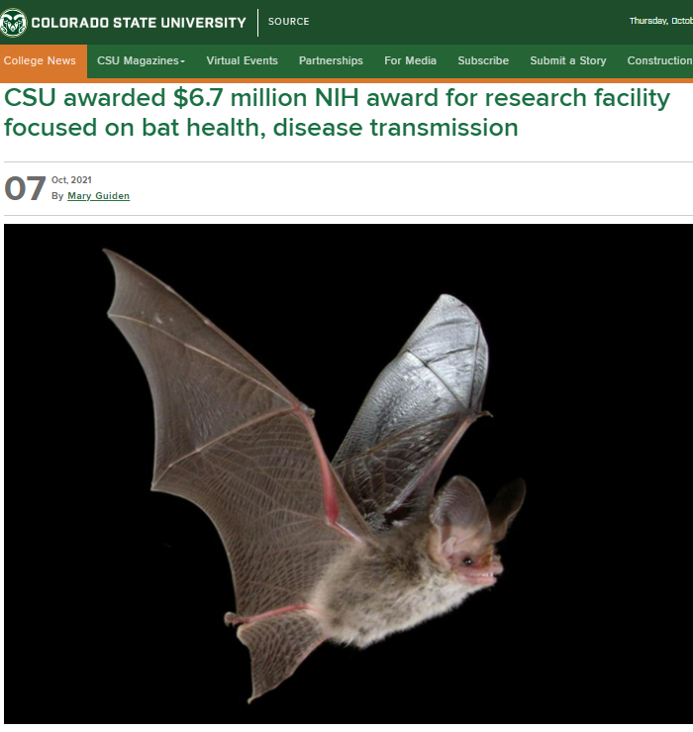
It is quite possible that lab research on bats and the coronaviruses they carry may be behind the outbreak of the COVID-19 pandemic. Risky research with minimal benefit to the health of the American people, and with a great risk of causing another pandemic, should be done only after an extremely intensive safety review and only under strict oversight, if done at all. Carefully evaluating all spending on bat research in the United States is a critical component of such oversight.

Live Bat Lab Background:

In 2016, a scientist with the now-debarred EcoHealth Alliance, proposed expanding live coronavirus research in the U.S., by importing and breeding bats that can harbor the dangerous and deadly Nipah virus, and also possibly the ebolavirus.

Your predecessor embraced this EcoHealth Alliance proposal and NIH awarded $6.7 million to CSU to create a bat breeding facility, which also planned a holding room for up to 212 horseshoe bats that harbor SARS-like viruses — those closely related to the virus that caused the COVID-19 pandemic.

Records indicate the taxpayers’ infusion to this bat facility has since grown to $12.9 million —$6.7 million from NIH’s Office of the Director, plus an additional $6.2 million from the National Institute of Allergy and Infectious Diseases (NIAID), most of which was awarded while Dr. Fauci was the NIAID director. This new bat facility is in addition to CSU’s existing captive, live bat colony of Jamaican fruit bats, which are also used in NIH-funded research.

Additional NIH-funded Live Bat Lab Research:

- NIH, prior to the COVID-19 pandemic, funded live bat research at Montana’s Rocky Mountain Laboratories (RML). RML and other NIH-funded researchers experimented with coronaviruses in live bats, including infecting live bats with a Chinese sarbecovirus discovered by the Wuhan Institute of Virology (WIV).

- NIH also funded the recent construction of a new, three-story, 120,000-square-foot research vivarium at RML in Montana, at a whopping cost of over $100 million. CSU’s 2022 planning documents indicate that RML planned to use the bats from CSU’s new bat facility to perform BSL-4-level Nipah and Ebola research in Montana on live bats, noting, “Studies planned with collaborators at Rocky Mountain Laboratories in Hamilton MT will assess the susceptibility of bats to Nipah virus and ebolaviruses.”

- NIH, prior to the COVID-19 pandemic, also funded live bat research at the U.S. Geological Services (USGS) National Wildlife Health Center (NWHC) in Wisconsin, purportedly from funds designated for influenza research. In 2018, the same Wisconsin USGS center partnered with EcoHealth Alliance and China’s WIV to propose creating a novel coronavirus in the lab, making a vaccine against it, and releasing the vaccine in bat caves in China.

The Centers for Disease Control and Prevention (CDC) in Atlanta also houses a live bat colony of Egyptian fruit bats used for research.

We shouldn’t be funding risky bat research in Wuhan, and we must examine the rationale for risky bat virus research in our U.S. labs. As Senator Ernst told The Washington Times, “When I disbarred EcoHealth from receiving taxpayer funds for sketchy research in China, that was not an invitation for the NIH to conduct the same shady experiments in our own backyard.” And it is still true what was said when we first learned of this facility, “We cannot allow any batty experiments of pandemic potential to be unleashed on our own shores. Americans have suffered enough from Fauci-funded risky research, …. The world cannot afford another lab leak, especially one on U.S. soil or near our military bases.”

Tragically, those tasked with overseeing NIH resources may have funded a deadly pandemic. We cannot repeat the mistakes of the past, and, as we have seen, there is a fine line between trying to prevent a pandemic and possibly causing one.

Dr. Bhattacharya, please provide our offices with a full list of NIH grants, contracts, subawards, cooperative agreements, intermural or interagency funding or research, or any other taxpayer-funded project with a drop of NIH funding that relates to live bats and was funded during any of the calendar years 2017, 2018, 2019, and/or 2020, or is currently funded, soon to be funded, and/or approved and not yet funded. Please include the complete application and/or NIH paperwork related to each award and include the year in which each project was awarded. Please provide this information by February 28, 2026, at the latest, and please reach out to our offices if you have any questions about this request.

Now is a time for increased biosafety and radical NIH transparency, and we appreciate and share your commitment to both those things and stand ready to assist you going forward.

Sincerely,

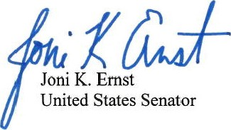


Paul A. Gosar, D.D.S.
Member of Congress

Cooperative Agreement FAIN U24AI165424, “Establishment of a Bat Resource for Infectious Disease Research,” $2.2 million obligated on September 15, 2025, $194,499 reported outlayed as of January 6, 2026, https://www.usaspending.gov/award/ASST_NON_U24AI165424_075; “Trump’s NIH plows ahead with bat lab to fuel virus research in U.S.; Bats would be used in Ebola, Marburg, COVID virus studies at American labs,” Stephen Dinan, The Washington Times, October 14, 2025, https://www.washingtontimes.com/news/2025/oct/14/donald-trumps-nih-plows-ahead-bat-lab-fuel-virus-research-us/.
R24AI165424 to Colorado State University, “Establishment of a Bat Resource for Infectious Disease Research,” September 22, 2023-August 31, 2028, $3.96 million obligated, $2.7 million outlayed, as of January 6, 2026, https://www.usaspending.gov/award/ASST_NON_R24AI165424_075; NIH to Colorado State University, Project Grant FAIN C06OD032019, $6.7 million, Sept. 2021-March 2025, “Establishment of the Bat Resource Center for the Study of Zoonotic Diseases …a vivarium…to successfully breed and maintain bats for use as animal models…and will serve as a national resource for others using bat models,” https://www.usaspending.gov/award/ASST_NON_C06OD032019_075; https://reporter.nih.gov/search/2K49KcGcJ0SjnBeB7D405g/project-details/10374306.
“Pre-White paper for discussion,” prepared by Jonathan Epstein, EcoHealth Alliance, Tony Schountz, CSU, and Vincent Munster, NIH RML, 2016, “The establishment of a research colony of Indian flying foxes (Pteropus medius) is critical to facilitate research in the United States that will test hypotheses related to the cellular mechanics of Nipah virus (NiV) and the host immune response, in vivo, in a wildlife reservoir species for Nipah virus. […] There are no bats available in the United States for research related to Pteropus physiology, immunology, and viral pathophysiology. NiV is an emerging, high consequence pathogen with 75% - 100% mortality in humans in Bangladesh, where is [sic] causes seasonal outbreaks of encephalitis. Currently, there is no effective treatment or vaccine for NiV,” https://usrtk.org/wp-content/uploads/2021/01/CSU-emails-Epstein-Schountz-bat-house.pdf.
“CSU awarded $6.7 million NIH award for research facility focused on bat health, disease transmission,” Oct. 7, 2021, https://source.colostate.edu/csu-awarded-6-7-million-nih-award-for-research-facility-focused-on-bat-health-disease-transmission/; NIH to Colorado State University, Project Grant FAIN C06OD032019, “Establishment of the Bat Resource Center for the Study of Zoonotic Diseases …a vivarium…to successfully breed and maintain bats for use as animal models…and will serve as a national resource for others using bat models,” Sept. 2021-March 2025, https://www.usaspending.gov/award/ASST_NON_C06OD032019_075; “Establishment of the Bat Resource Center for the Study of Zoonotic Diseases”, NIH Office of the Director 1C06OD032019-01, https://reporter.nih.gov/search/2K49KcGcJ0SjnBeB7D405g/project-details/10374306.
“Horseshoe Bat (Rhinolophus affinis) holding area, page 320-340 of 412-page 2022 CSU Chiropteran Research Facility meeting document, since deleted, but archived here: https://web.archive.org/web/20230530144943/https://csusystem.edu/wp-content/uploads/sites/7/2020/09/February-BOG-Meeting-Materials-2022-Final-post-meeting.pdf.
$6.7 million (FY2021-NIH Office of the Director), $1.7 million (FY22 NIAID), $2.3 million (FY24 NIAID), $2.2 million (FY25 NIAID), https://reporter.nih.gov/search/efJXc4871E61cYlI3zS6OQ/projects/charts.
“Active projects are funded by NIAID to develop a better understanding as to why bats can host such high impact human pathogens that cause no discernible disease in bats,” https://labs.vetmedbiosci.colostate.edu/schountz/, accessed January 6, 2026; https://reporter.nih.gov/search/g-wqQANZHEC79Ys-eChvyA/projects.
“SARS-Like Coronavirus WIV1-CoV Does Not Replicate in Egyptian Fruit Bats (Rousettus aegyptiacus),” Neeltje van Doremalen, Ralph S Baric, Vincent J Munster, et al., December 19, 2018, Viruses, https://pmc.ncbi.nlm.nih.gov/articles/PMC6316779/. “This work was supported by the Intramural Research Program of the National Institute of Allergy and Infectious Diseases (NIAID), National Institutes of Health (NIH), and a research grant from NIH AID (AI089728).” R01AI08728 “Receptor recognition mechanisms of coronaviruses” received $4.1 million in NIH NIAID funding from 2010-2021, to the University of Minnesota’s Principal Investigator (PI) Fang Li, https://reporter.nih.gov/search/lLvx68K3Q0u2oP7IzMBT8Q/project-details/8651407; Following publication of this bat research paper, $1.1 million of the NIAID grant is shown to have been subawarded to the University of North Carolina at Chapel Hill, see subaward N005402801: https://www.usaspending.gov/award/ASST_NON_R01AI089728_075; “Bat Severe Acute Respiratory Syndrome-Like Coronavirus WIV1 Encodes an Extra Accessory Protein, ORFX, Involved in Modulation of the Host Immune Response,” Zeng LP, Gao YT, Ge XY, Zhang Q, Peng C, Yang XL, Tan B, Chen J, Chmura AA, Daszak P, Shi Z, J Virol, June 24, 2016, https://pmc.ncbi.nlm.nih.gov/articles/PMC4936131/.
“New RML Vivarium Opens for Research,” June 7, 2024, “RCMC’s new vivarium is a centralized animal receiving and holding building that will support all biosafety levels of research throughout the RML campus and research projects on virology, bacteriology and viral diseases including work on SARS-CoV-2. The facility will provide expanded capabilities for studies with exotic species along with special imaging equipment and a multi-vector insectary,” https://nihrecord.nih.gov/2024/06/07/new-rml-vivarium-opens-research; “This new Rocky Mountain Laboratories – Comparative Medicine Center (RCMC) will be a three-story vivarium facility… It will contain 35 holding rooms, 28 procedure rooms and 24 specialty rooms along with autoclaves and cage washrooms. This new vivarium facility will provide important program support including all Biosafety Level 2 (BSL-2) breeding, holding and experimental programs, as well as quarantine for animals destined for BSL-3 and BSL-4 studies in laboratories at RML,” “Cost $125M,” https://orf.od.nih.gov/Construction/ORFSignatureProjects/Pages/Rocky-Mountain-Laboratories-%E2%80%93-Comparative-Medicine-Center-(RCMC).aspx; Delivery Order PIID 75N99022F00001, $115 million outlayed to Hensel Phelps Construction Co of Tysons Corner, VA, “C104385 - BUILDING B VIVARIUM PROJECT, RML,” October 2021-March 2025, https://www.usaspending.gov/award/CONT_AWD_75N99022F00001_7529_75N99019D00016_7529.
Page 325 of 412, 2022 CSU Chiropteran Research Facility meeting document, since deleted, but archived here: https://web.archive.org/web/20230530144943/https://csusystem.edu/wp-content/uploads/sites/7/2020/09/February-BOG-Meeting-Materials-2022-Final-post-meeting.pdf
June 3, 2020, email from Sleeman, Jonathan M to Reilly, James F: “We received approval from a collaborator to redirect funding from an NIH grant (Center for Excellence in Influenza Research and Surveillance) to use funds for the challenge study and we also redirected USGS base funds to cover the costs of staff salaries. Please see attached letter from the collaborator. …The challenge study with bats to determine the ability of the virus to infect bats lead by the NWHC. …The challenge study commenced on May 1 [2020] and all the bats were euthanized on May 22 [2020],” pages 71-74 of 206-page 2023 FOIA production to Protectpublicstrust.org, https://protectpublicstrust.org/wp-content/uploads/2023/06/USGS-22-6721-First-production-combined.pdf.
“We will use the NWHC captive bat colony”, page 7 of 75, 2018 DARPA DEFUSE application, https://drasticresearch.files.wordpress.com/2021/09/main-document-preempt-volume-1-no-ess-hr00118s0017-ecohealth-alliance.pdf.
“The captive-born bats used in this study originated from the ERB [Egyptian rousette bats] breeding colony at the Centers for Disease Control and Prevention (CDC, Atlanta, GA, USA). This MARV-free colony was established from wild-caught ERBs imported from Uganda.” Schuh AJ, et al., “Egyptian rousette bats maintain long-term protective immunity against Marburg virus infection despite diminished antibody levels,” Sci Rep., August 18, 2017, https://pmc.ncbi.nlm.nih.gov/articles/PMC5562751/.
“Trump’s NIH plows ahead with bat lab to fuel virus research in U.S.; Bats would be used in Ebola, Marburg, COVID virus studies at American labs,” Stephen Dinan, The Washington Times, October 14, 2025, https://www.washingtontimes.com/news/2025/oct/14/donald-trumps-nih-plows-ahead-bat-lab-fuel-virus-research-us/.
“America's frightening new bat lab: $12m taxpayer-funded NIH research facility in Colorado will import bats from Asia and infect them with deadly diseases - in project with China-linked scientists,” Alexa Lardieri, Daily Mail, November 10, 2023, https://www.dailymail.co.uk/health/article-12720837/nih-covid-lab-colorado-leak-theory.html.

